
NORTH STAR TAI CHI - 2023 Classes Calendar

Jan - Mar 2023

JANUARY |  |  |  |  |  |  | FEBRUARY |  |  |  |  |  |  | MARCH
S | M | T | W | T | F | S | S | M | T | W | T | F | S | S | M | T | W | T | F | S
1 | 2 | 3 | 4 | 5 | 6 | 7 |  |  |  | 1 | 2 | 3 | 4 |  |  |  | 1 | 2 | 3 | 4
8 | 9 | 10 | 11 | 12 | 13 | 14 | 5 | 6 | 7 | 8 | 9 | 10 | 11 | 5 | 6 | 7 | 8 | 9 | 10 | 11
15 | 16 | 17 | 18 | 19 | 20 | 21 | 12 | 13 | 14 | 15 | 16 | 17 | 18 | 12 | 13 | 14 | 15 | 16 | 17 | 18
22 | 23 | 24 | 25 | 26 | 27 | 28 | 19 | 20 | 21 | 22 | 23 | 24 | 25 | 19 | 20 | 21 | 22 | 23 | 24 | 25
29 | 30 | 31 |  |  |  |  | 26 | 27 | 28 |  |  |  |  | 26 | 27 | 28 | 29 | 30 | 31

Half an hour after all classes

Tai Chi Chuan Practice for students that have at least Level One or Tai Chi Sabre for students that have at least Level Two

# | 1 - 2 pm Tai Chi Ongoing Class @ St. Michael & All Angels Anglican Church
# | 7 - 8 pm Tai Chi Ongoing Class @ St. Michael & All Angels Anglican Church
# | 9 - 10 am Tai Chi Sabre Class @ Dunlop United Church
# | 10 - 11 am Tai Chi Chuan Class @ Dunlop United Church

NORTH STAR TAI CHI - 2023 Classes Calendar

TUESDAY CLASSES: | WEDNESDAY CLASSES:
St Michael & All Angels Anglican Church  397 Springbank Drive, London ON  Springbank & Kernohan Pkwy across from Giant Tiger | St Michael & All Angels Anglican Church  397 Springbank Drive, London ON  Springbank & Kernohan Pkwy across from Giant Tiger
TIME: 1:00 – 2:00 pm | TIME: 7:00 – 8:00 pm

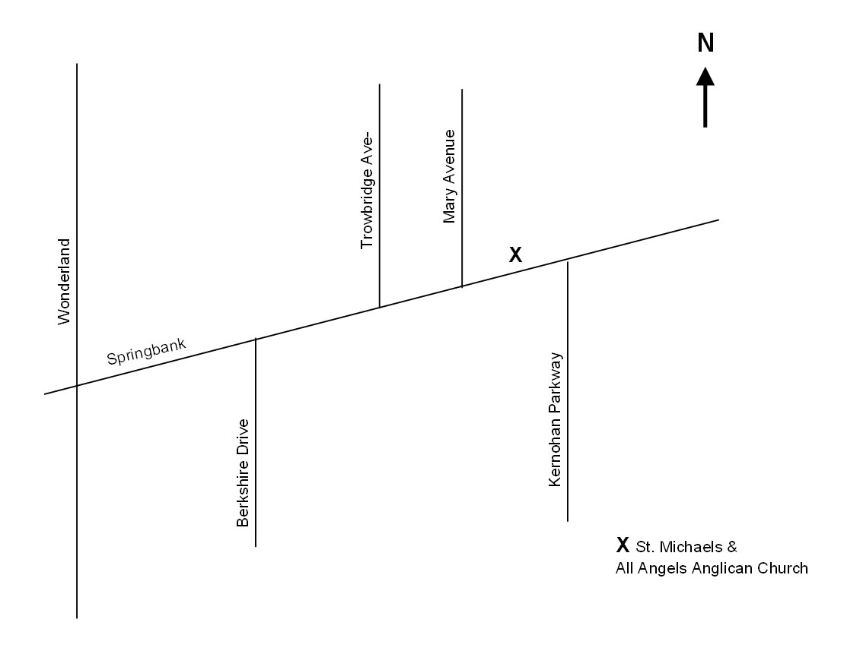
For more information please contact:

Perry Kloibhofer Phone: (519) 649-2780
North Star Tai Chi ~ London E-mail: n.star.tai.chi@rogers.com
Web: www.northstartaichi.ca

